**P**

**Date of Submission :- /11/2024**

**……………………**

**Sign**

**Submitted By :- Mumtaj Ali Muslaman**

**UID :- 23BCA10662**

**Branch :- BCA**

**Subject Name :- Desktop Publishing**

**Subject Code :- 23CAP-204**

**Submitted To**

***Suman Acharya***

**roject on Crafting Front & Back Cover of Book**

**Table of Contents**

1. Overview of Adobe Photoshop
2. Objectives and Tasks
3. Adobe Photoshop Tools and Techniques Used
4. Design Process
   * 6.1 Conceptualization and Planning
   * 6.2 Creating Visual Elements
   * 6.3 Arranging and Structuring Layers
   * 6.4 Final Adjustments and Export
5. Result and Output Summary
6. Learning Outcomes
7. Challenges Faced and Solutions
8. Conclusion and Future Enhancements
9. **Overview of Adobe Photoshop**

Adobe Photoshop is one of the most widely used software applications for image editing, graphic design, and digital art. Originally developed by Thomas and John Knoll and first released in 1988, it has since evolved into a highly sophisticated tool used by professionals and enthusiasts alike across various industries, including photography, web design, advertising, and multimedia. Here’s an overview of its features, functionalities, and the impact it has had on the creative industry:

* **Purpose and Uses**
* Adobe Photoshop is primarily used for editing raster (bitmap) images, meaning it operates on pixels rather than vector data. Its main uses include:
* **Photo Editing and Retouching**: Photoshop allows users to enhance photographs by adjusting color, brightness, and contrast, as well as correcting blemishes and imperfections.
* **Graphic Design**: Photoshop is equipped with tools to create digital artwork, posters, flyers, business cards, and other visual elements.
* **Web and UI Design**: Many web designers use Photoshop to create website mockups, wireframes, and elements for user interfaces.
* **Digital Painting and Illustration**: Artists use Photoshop's brushes and layering system to create digital paintings and illustrations.
* **3D Modeling and Texturing**: Photoshop has a suite of 3D tools for creating and editing 3D models, adding texture, and integrating them into designs.
* **Video Editing**: Although it’s not primarily a video editor, Photoshop offers basic tools for video and animation editing.
* **Tools of Adobe Photoshop**

**1. Selection Tools**

Selection tools allow users to isolate specific parts of an image to edit them separately.

* Move Tool: Used to move selected objects, layers, or parts of an image.
* Marquee Tools (Rectangle, Elliptical, Single Row, Single Column): Create rectangular, elliptical, or single-line selections.
* Lasso Tools:
  + Lasso Tool: Draws freeform selection borders.
  + Polygonal Lasso Tool: Creates straight-edge selections.
  + Magnetic Lasso Tool: Clings to the edges of objects for precise selection.
* Quick Selection Tool: Selects areas based on color and texture similarity. Good for quickly selecting complex shapes.
* Magic Wand Tool: Selects pixels with a similar color. Useful for selecting backgrounds or single-colored areas.

**2. Crop & Slice Tools**

These tools allow users to trim or slice images and prepare them for export or web use.

* Crop Tool: Crops images to remove unwanted parts and adjust the frame.
* Perspective Crop Tool: Crops images while adjusting the perspective, useful for fixing angles.
* Slice Tool: Divides an image into smaller sections for web design and saving optimized sections individually.
* Slice Select Tool: Allows you to select individual slices and adjust their properties.

**3. Measuring Tools**

Measuring tools help in measuring dimensions, angles, and creating guides within the canvas.

* Eyedropper Tool: Samples colors from the image and sets the selected color as the foreground color.
* Color Sampler Tool: Adds persistent color sample points to analyze multiple colors in an image.
* Ruler Tool: Measures distances and angles on the image.
* Note Tool: Adds text notes on the canvas for collaborative work or reminders.
* Count Tool: Counts objects in an image, useful for analysis or counting items in a large composition.

**4. Retouching and Painting Tools**

These tools are used to retouch images, paint new elements, and enhance existing content.

* Spot Healing Brush Tool: Quickly removes blemishes and imperfections by blending them with surrounding pixels.
* Healing Brush Tool: Allows for more control over blending, sampling a source area to cover imperfections.
* Patch Tool: Repairs selected areas by sampling from another part of the image.
* Content-Aware Move Tool: Moves selected elements within an image and fills in the gap intelligently.
* Red Eye Tool: Removes red-eye from flash photography.
* Brush Tool: Paints on the image in a freeform manner with customizable brush settings.
* Pencil Tool: Creates hard, pencil-like strokes.
* Clone Stamp Tool: Samples pixels from one part of the image to paint over another, useful for duplicating or removing elements.
* Pattern Stamp Tool: Paints a selected pattern on the image.
* History Brush Tool: Reverts parts of an image to an earlier state based on the history panel.
* Art History Brush Tool: Paints stylized strokes using data from previous states.
* Eraser Tool: Erases pixels to make them transparent or removes part of a layer.
* Background Eraser Tool: Erases backgrounds based on color sampling.
* Magic Eraser Tool: Erases all pixels of a selected color or transparency.
* Gradient Tool: Creates a gradual blend between multiple colors.
* Paint Bucket Tool: Fills an area with a solid color based on color similarity.
* Blur Tool: Blurs parts of the image to reduce detail.
* Sharpen Tool: Enhances the focus and detail of specific parts of an image.
* Smudge Tool: Blends pixels by dragging them, useful for painting and retouching.
* Dodge Tool: Lightens specific areas of an image.
* Burn Tool: Darkens specific areas of an image.
* Sponge Tool: Adjusts saturation by making colors more or less intense.

**5. Drawing and Type Tools**

These tools are for adding shapes, text, and vector elements to an image.

* Pen Tool: Creates precise paths and shapes, commonly used for creating selections and vector shapes.
* Freeform Pen Tool: Draws freehand paths and shapes.
* Curvature Pen Tool: Allows for simpler and more intuitive path creation by placing anchor points.
* Add Anchor Point Tool: Adds anchor points on paths for more complex shapes.
* Delete Anchor Point Tool: Removes anchor points from paths.
* Convert Point Tool: Adjusts the angles and curves of paths for precision editing.
* Horizontal Type Tool: Adds horizontal text to an image.
* Vertical Type Tool: Adds vertical text to an image.
* Horizontal Type Mask Tool: Creates a selection in the shape of horizontal text.
* Vertical Type Mask Tool: Creates a selection in the shape of vertical text.

**6. Shape and Navigation Tools**

These tools help with creating shapes, navigating, and managing the view of the workspace.

* Rectangle Tool: Creates rectangles and squares.
* Rounded Rectangle Tool: Creates rectangles with rounded corners.
* Ellipse Tool: Draws circles and ovals.
* Polygon Tool: Creates polygons with a specified number of sides.
* Line Tool: Draws straight lines with adjustable thickness.
* Custom Shape Tool: Adds custom shapes, like arrows and stars, which are pre-defined in Photoshop.
* Hand Tool: Moves the view around when zoomed in on the image.
* Rotate View Tool: Rotates the canvas without affecting the image’s actual orientation.
* Zoom Tool: Zooms in and out on the canvas for better detail visibility.

**7. Color and Adjustment Tools**

These tools allow for adjusting colors and applying corrections to images.

* Color Picker: Selects the foreground and background colors.
* Gradient Map Tool: Maps gradients based on the image’s brightness levels, adding color effects.
* Levels: Adjusts brightness, contrast, and tonal balance.
* Curves: Fine-tunes brightness, contrast, and colors in the image.
* Hue/Saturation: Adjusts color properties like hue, saturation, and brightness.
* Brightness/Contrast: Basic adjustment for brightness and contrast.
* Exposure: Adjusts exposure levels to control lightness.
* Vibrance: Enhances muted colors while protecting already saturated colors.
* Color Balance: Adjusts the color balance across shadows, midtones, and highlights.
* Black & White: Converts a color image to black and white with fine control over color intensity.
* Photo Filter: Applies filters for color correction or warming/cooling effects.

**8. 3D Tools**

In Photoshop, 3D tools allow you to create and manipulate 3D objects.

* 3D Panel: Manages 3D objects, lights, and materials.
* 3D Tools (Rotate, Pan, Slide, Scale, etc.): Adjust the view and properties of 3D objects.

**9. Other Important Features**

Photoshop also has some additional features worth mentioning:

* Layers Panel: Manages image layers for organizing elements.
* Layer Styles: Adds effects to layers, such as shadows, glows, and strokes.
* History Panel: Tracks changes made to the image and allows reverting to previous states.
* Actions Panel: Records and plays back a series of steps, useful for repetitive tasks.
* Filters: Applies effects like blur, sharpen, distort, and artistic effects.
* **Overview of Book Cover**

Designing a book cover in Adobe Photoshop involves creating both the front and back covers in a cohesive way that represents the book’s theme and captivates potential readers. The **front cover** serves as the first impression, so it should be visually engaging and clearly convey the book’s essence. This includes a prominent title and subtitle, usually in a font that reflects the genre (like serif fonts for traditional themes or sans-serif for modern ones), alongside the author’s name, which can be placed near the top or bottom of the cover. Supporting the text are visual elements such as images, textures, or gradients, which should complement the book's genre. Colors are also crucial, as they evoke certain moods—for example, dark tones for a thriller or bright hues for a lighthearted story. Adding effects like shadows or glows around text can enhance readability, while subtle textures provide depth.

1. **Objectives and Tasks**

* **Objective:**

Create a visually compelling front and back cover that attracts readers and reflects the book’s genre and content. This includes carefully selected visuals, typography, and colors to evoke the right emotions and aesthetics.

* **Tasks:**
  + Research: Gather inspiration and reference covers of similar books. Identify what works well and consider any unique elements that could set this design apart.
  + Conceptualize: Sketch ideas for the layout, or outline a list of key elements that must be included (title, subtitle, author’s name, spine text, and barcode on the back cover).
  + Design: Begin creating the cover in Photoshop, ensuring all visual and textual elements are aligned and aesthetically pleasing.
  + Finalize: Make final tweaks for balance, alignment, and color before exporting the design in the required formats.

1. **Adobe Photoshop Tools and Techniques Used**

• **Key Tools:**

* Layers: Fundamental for organizing and separating design elements like background, images, text, and effects.
* Shape Tool: Useful for adding geometric elements, borders, and other shapes that enhance the layout.
* Text Tool: For adding title, subtitle, and author’s name. Font choice is crucial here, as it sets the tone for the cover.
* Gradient Tool: Adds depth and smooth transitions in backgrounds or over images.
* Adjustment Layers: Used to tweak colors, brightness, contrast, and saturation without altering the original images directly.
* Blending Modes: These add effects to layers, helping combine images and textures seamlessly.

• **Techniques:**

* Layer Masking: This allows selective visibility, which is helpful for creating smooth blends and removing unwanted parts of images.
* Text Effects: Adds styles like shadows, bevel, or glow to text, making it stand out or integrate with the background.
* Texture Overlay: Applying subtle textures to give the cover a tactile or vintage feel, often through blending modes like Overlay or Soft Light.
* Filters and Effects: Applying filters like Gaussian Blur for background depth or Sharpen for clarity on focal points.

1. **Design Process**

**4.1 Conceptualization and Planning**

* Identify the Cover’s Purpose and Audience: Define who the target audience is and what the book’s genre is (e.g., thriller, romance, self-help). Each genre typically has distinct stylistic elements.
* Sketch Ideas or Create a Mood Board: Visualize different layouts by hand or use a digital tool. Include font samples, color swatches, and inspiring visuals.
* Define Visual Hierarchy: Decide which elements should be prominent (e.g., title should stand out more than the subtitle). This helps guide the viewer’s eye naturally.

**4.2 Creating Visual Elements**

* Select Images and Backgrounds: If the cover includes images, they should be high-quality and relevant. Backgrounds can be simple gradients, abstract textures, or images that match the theme.
* Design with Shapes: Use the Shape Tool to add elements like lines or borders, creating structure and focus areas. Shapes can also be adjusted with opacity and blending for subtle effects.
* Add Typography: Title and author’s name placement are crucial. Font styles should match the tone: serif fonts often feel more traditional, while sans-serif can be modern or minimalistic.

**4.3 Arranging and Structuring Layers**

* Layer Organization: Name layers appropriately and group them by type (e.g., all text in one group, all backgrounds in another). This keeps the workspace tidy and allows for easier adjustments.
* Hierarchy with Layers: Keep the most prominent elements at the top. For example, the title should be on top of other visual elements to ensure clarity and readability.
* Use Layer Effects for Emphasis: Effects like Drop Shadow and Stroke help make elements (especially text) stand out from the background, ensuring readability even from a distance.

**4.4 Final Adjustments and Export**

* Fine-Tune Color and Lighting: Use adjustment layers like Color Balance, Brightness/Contrast, and Levels to ensure the design has the right mood and looks polished.
* Resolution Check: Ensure that all elements are at least 300 dpi for printing quality. If the cover will also be used digitally, export it in web-friendly resolutions (e.g., 72 dpi for online previews).
* Export in Print-Ready Format: Export the design in .JPEG, .PDF, or .TIFF formats, depending on print requirements. CMYK color mode is essential for accurate print color representation.
* **Text Arrangement**: Detail the placement of text sections, such as the “About Me” and “Contact” areas. Discuss font choice, size, and color to ensure readability and harmony with the overall design.
* **Adding Visual Effects**: Describe how effects like drop shadows, outer glows, and strokes were applied to make certain elements pop. Mention any use of blending modes to integrate elements seamlessly.

**4.4 Final Adjustments and Export**

* **Refining Details**: Mention the final steps taken to refine alignment, colors, and typography. Adjustments were made to ensure each element was aligned properly and visually balanced.

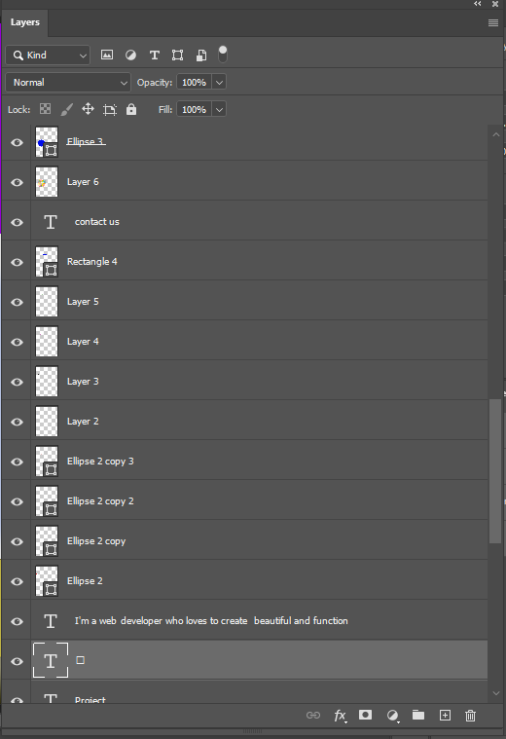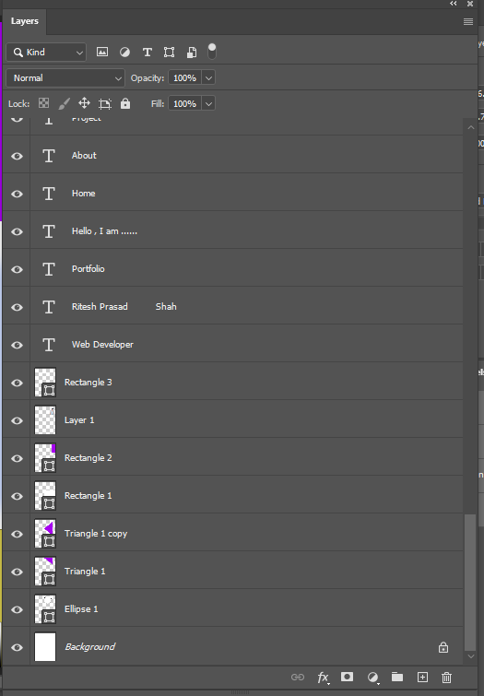

* 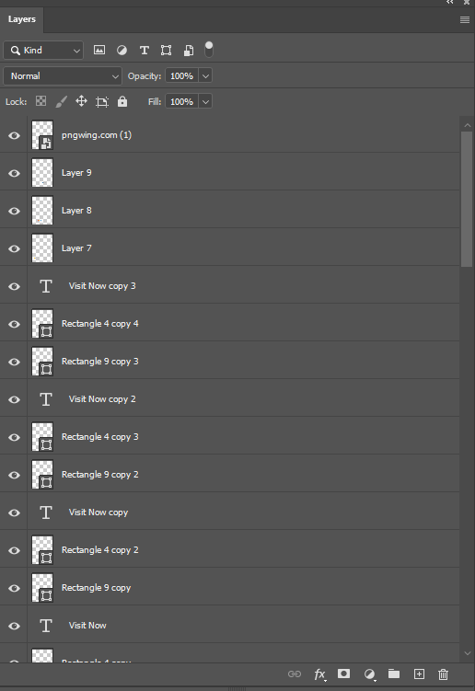**Exporting for Web**: Describe the export process, including choosing the right resolution and file format for optimal web performance. Export settings, such as JPEG quality or PNG transparency, were chosen based on the needs of the final layout.

1. **A screenshot of a computer

   Description automatically generatedResult and Output Summary**

* **Outcome**: The final cover design meets all objectives, including aesthetic appeal, genre appropriateness, and readability. The design feels cohesive, with a balanced layout and colors that align with the book’s theme.
* **Exported** Files: Saved in high-resolution for printing (JPEG/TIFF) and a separate web-resolution version for digital sharing if required**.**

1. **Learning Outcomes**

* **Photoshop Proficiency**: Gained hands-on experience using various Photoshop tools, including selection tools, layer management, and blending options.
* **Design Principles**: Developed an understanding of layout composition, color theory, and typography, and how these principles are applied to create visually appealing designs.
* **Layer Management Skills**: Improved skills in organizing and structuring layers for efficient editing and better workflow in Adobe Photoshop.
* Improved understanding of **Photoshop’s layer management** and **advanced tools** like blending modes and masks.
* Gained experience in **typography** and **visual hierarchy** to create balanced and readable designs.
* Enhanced ability to combine **creative planning** with practical tool knowledge to achieve professional results.

1. **Challenges Faced and Solutions**

* **Challenge 1: Color Harmony**
  + **Description**: Finding the right color palette to match the designer’s personal brand and style.
  + **Solution**: Experimented with different color schemes and used online color tools to achieve a cohesive look.
* **Challenge 2: Layer Organization**
  + **Description**: Managing multiple layers in Photoshop became challenging as more elements were added.
  + **Solution**: Grouped related layers, named each layer clearly, and used folders to keep the workspace organized.
* **Challenge 3: Text Readability**
  + **Description**: Ensuring text was readable over complex backgrounds.
  + **Solution**: Used contrasting colors, drop shadows, or semi-transparent overlays behind the text to improve readability.

1. **Conclusion and Future Enhancements**

**• Conclusion:**

The project fulfilled the objectives with a design that’s both visually appealing and aligned with the book’s theme.

**• Future Enhancements:**

* Experiment with 3D elements for more dynamic covers.
* Explore textured brushes or digital painting techniques to add depth.
* Try more interactive or animated covers if digital versions are required.